|  |
| --- |
| Circle Language Spec: Commands |

## Executable Command Object Redirection in a Diagram

The concept of execution object redirection is explained in the article *Execution Object Redirection*. The current article explains its expression in a diagram.

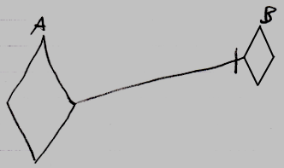

Active command symbol A is a diamond shape, because it is an *active* command. Active command symbol A redirects its object to the active command symbol B. The redirection from command A to command B is displayed as a solid line, which is an object line. This makes symbol A a reference to an execution running elsewhere.

You can also have an active reference to an inactive command:

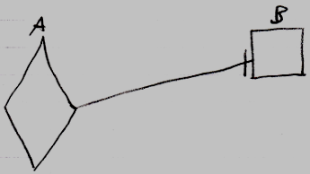

But this situation is very uncommon. You can not run command B through symbol A, because an inactive command object can never be run.